

***by***



**October 31th, 2017**

**APLSoft © 2017**

**Adrián Francés Lillo**

**Pablo López Iborra**

**Luis González Aracil**

**What we are…**

APLSoft was created in September 2017 by a group of students from University of Alicante, in order to create a project programmed in Z80 assembly for the CPCRetroDev 2017. Our name was made by grouping our first name’s initials in a way that sounds similar to “apple” and adding the word “soft” (from the compound word “software”).

**What our game is…**

Initially we wanted to make a Phantis like game, with very different levels and mechanics (spaceships, platforms, horizontal scroll…). We were discouraged by our teacher, who wisely recommended us to start with a simpler project.

That’s why we decided to remove the spaceship component of Phantis, having a platform-adventure-shooter game in the end. So, we focused on a game we already knew, Gryzor, predecessor of Contra games.

After that, we decided we wanted our playable character to be a secret agent, James Bond like, and we called him Agent 006, as a joke. We don’t know how, but the joke remained and now is the name of our game.

**What development was…**

We didn’t know how to program in Z80 assembly. Actually, we didn’t know how to program in any assembly at all, but we had to. Our first 2-3 weeks of developing… well, they weren’t developing, they were learning! Thanks to Fran Gallego course in assembly, we learned how to understand machine code firstly, and assembly code later. Once we “knew” how to program in assembly, it was the time for starting with some basics.

**First week:** after our first week, we had a really simple character that could move left and right, jump and shoot to the right. We also had three static maps, and we could go from one to the other when we were near the borders. The visual style was quite basic, but better than just using boxes!

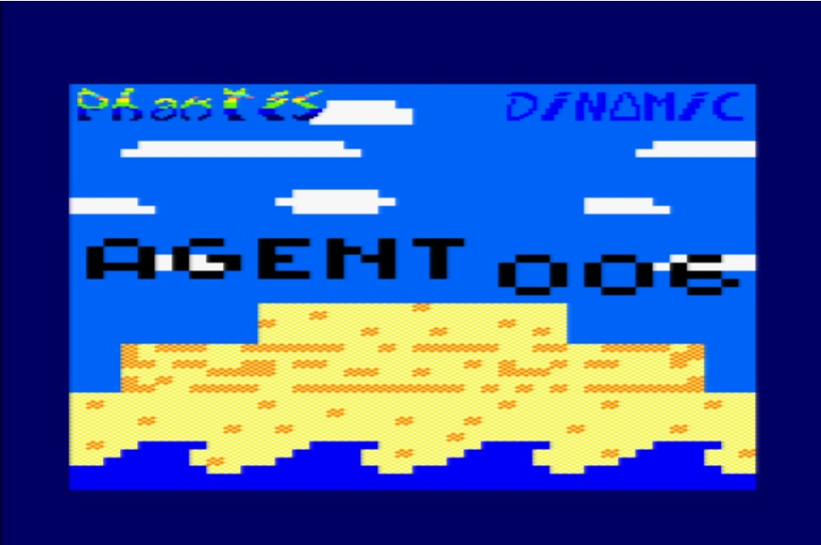

Image 1 – Our very first map

**Second week:** we added a basic enemy, the turret, who stayed still, shooting in loop. We also gave out player the ability to shoot in any direction and he could also kneel. We added collisions with ground and a prefabricated gravity. We tried adding more stuff, like animations and compressed tilemaps, but we failed.

C:\Users\Luis\AppData\Local\Microsoft\Windows\INetCache\Content.Word\James Bond 6.png

Image 2 - Our player

C:\Users\Luis\AppData\Local\Microsoft\Windows\INetCache\Content.Word\Turret.png

Image 3 - The turret

**Third week:** after talking with our teacher, Fran Gallego, we decided that we needed tilemap compression if we wanted to make a game that had more than 2 or 3 static maps. After some discussion and research, we decided that every screen would be composed by eight smaller tilemaps, that could be ordered in different patterns. Every tilemap would have a maximum of 16 tiles and would be compressed half its size. Also, our player would advance by half-map in half-map, so every new screen would always have a part of the previous map and a part of the new map, giving a sense of continuity and coherence to our game. We also started implementing animation system.

C:\Users\Luis\AppData\Local\Microsoft\Windows\INetCache\Content.Word\James Bond 8.png

Image 4 - Our player with simple animation sprites

**Fourth week:** making the map system was way harder than we thought, and we needed an extra way in order to finish it the way we wanted. After that, we started adding more enemies (soldiers with basic AI and moving obstacles) and a system of collectable characters and powerups. We also implemented double buffer system.

C:\Users\Luis\AppData\Local\Microsoft\Windows\INetCache\Content.Word\obstacle.png

Image 5 - The obstacle

C:\Users\Luis\AppData\Local\Microsoft\Windows\INetCache\Content.Word\powerups.png

Image 6 – Powerups

**Fifth week:** no one said it was going to be easy, but after a month, we had all our game mechanics completed. We spent this week in game polishing and optimization, art polishing and we started level creation. We also added a menu screen, froze the game to 17 frames per second and created the music and sound effects.

C:\Users\Luis\AppData\Local\Microsoft\Windows\INetCache\Content.Word\player.png

Image 7 - Our handsome player

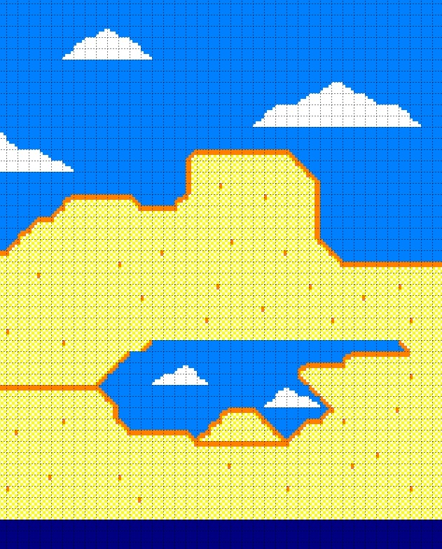

Image 8 - Our not so sharp map

**Sixth week:** last week, no time left for the CPCRetroDev and… everything done but we have nothing yet! We were on our last week, and even is we knew we had a lot of content created, we didn’t have levels. An adventure game with no adventure!

We had a lot to do, we had to correctly debug our game, create all tilemaps (about 70), maps and levels (more than 60!). We also had to add a loading screen to the game and joystick controls. We died… almost.

**What we ended up with…**

Is our game like we would have wanted? No.

Is our game completely free of bugs, with animations and sound for everything? No.

Is our game perfect? No.

Are we proud of our game? Oh God, YES!

Our game is not perfect, and if we had had more time, we would have loved to add tones of more things to it. We think it’s a finished game, but maybe it’s not a polished one… But we have ended with what we think it is a good-looking game with a lot of different mechanics and systems implemented. We are just students, and we just had a month and a half for developing the game, with no previous knowledge of assembly nor of the Z80, and we have ended up with this! We can’t be more surprised, we can’t be more satisfied, we can’t be more motivated.

CPCRetroDev has been a real challenge for us, one from which we have suffered a lot, but we have learned and enjoyed more! And we are proud of what we got.

Only thing we can say is… see you next year!